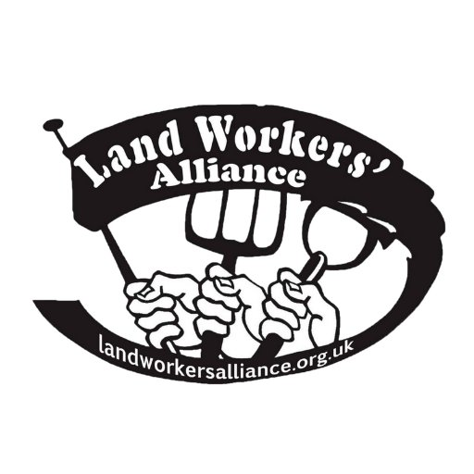

01/04/2020

To Whom It May Concern:

FARMER: ESSENTIAL TO TRAVEL TO WORK OR AS PART OF WORK DUTIES

The person <INSERT NAME> in possession of this letter is working as a farmer or farm worker, and is a member of the Landworkers’ Alliance, a national union for small and medium scale farmers and land workers.

Food workers have been classified as key workers and food production listed as an essential work activity, and as such, the holder of this letter has permission to travel to their place of work or as part of their work activities. We request they are still able to travel to work or as part of their job, go out on deliveries, or carry out other travel related to farm activity.

If you have any questions, please contact us on the following numbers:
Steph Wetherell, 07494 363 852.
Andrew Kirby, 07582 883 093.

Yours sincerely

<YOUR NAME>
<JOB TITLE>
<BUSINESS NAME>

